G. Rupa Manasa 27-12-2023

PySpark Coding Assessment

**Implement Processing JSON and CSV data with PySpark:**

Loading the data using csv file and showing the first 5 rows.

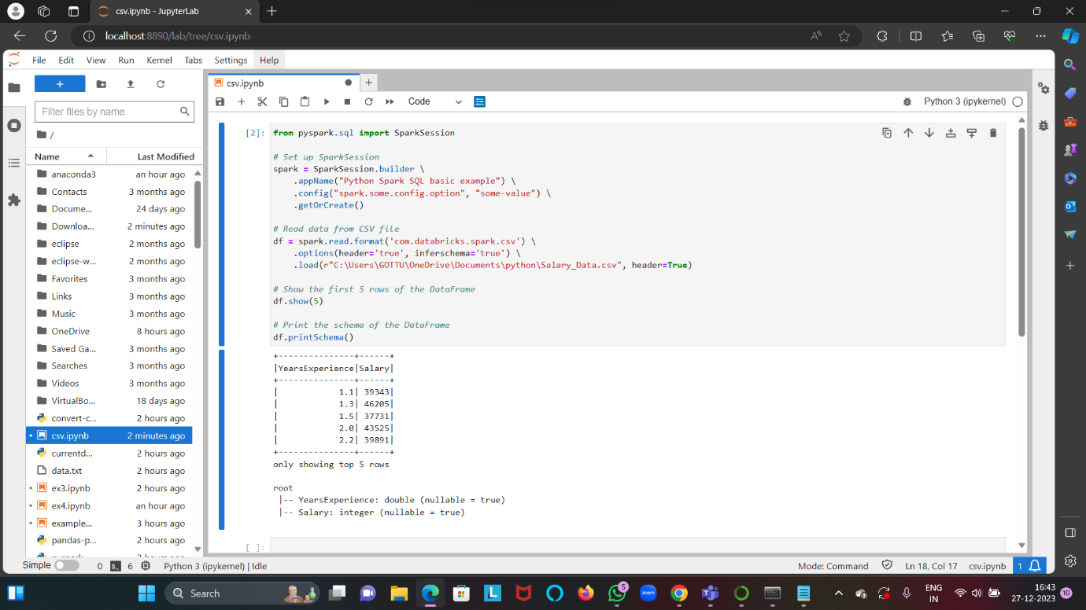

**Explain ETL (Extract, Transform, Load) with PySpark:**

Extract: Retrieve data from various sources like databases, files, or APIs.

Transform: Clean, aggregate, and manipulate data to fit your analysis needs.

Load: Store the transformed data into a database or data warehouse for analysis.

Extracting the csv file

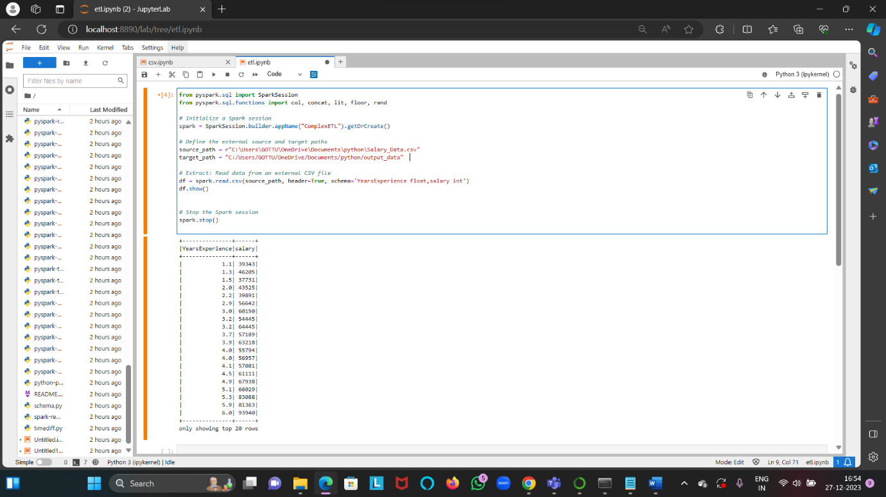

Transform: adding a new column “monthly_salary”

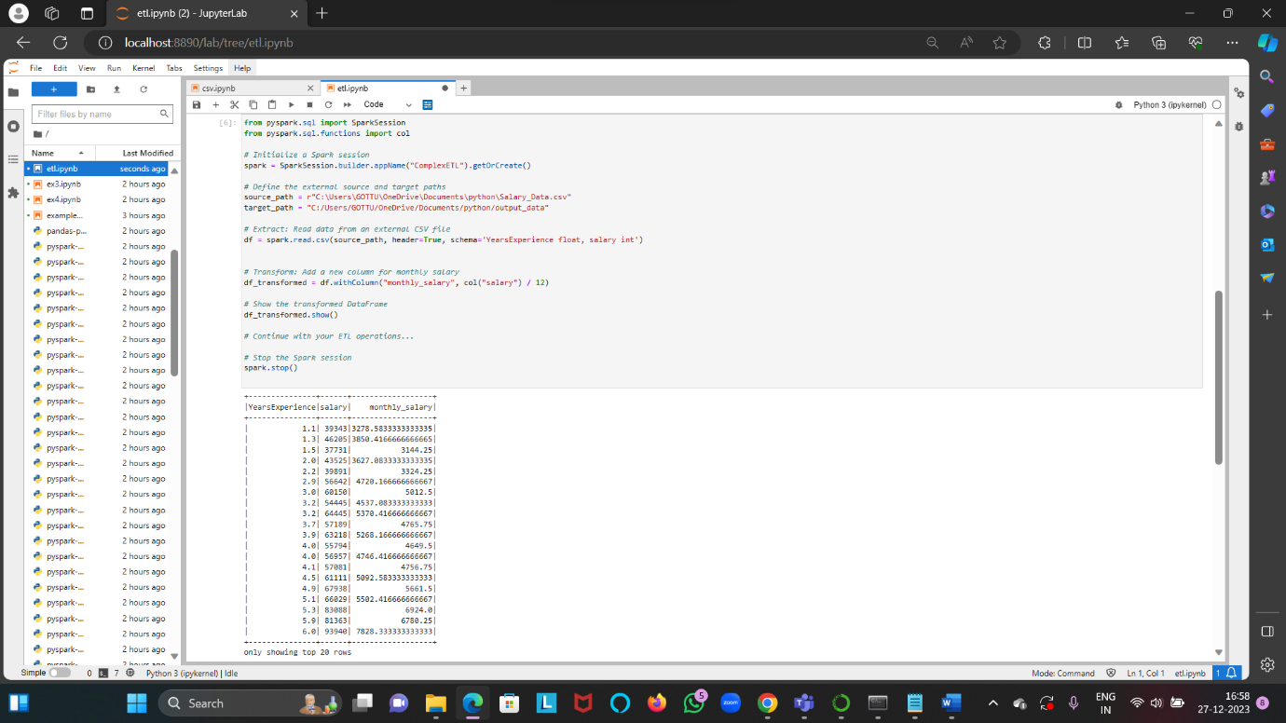

Loading the file into another location.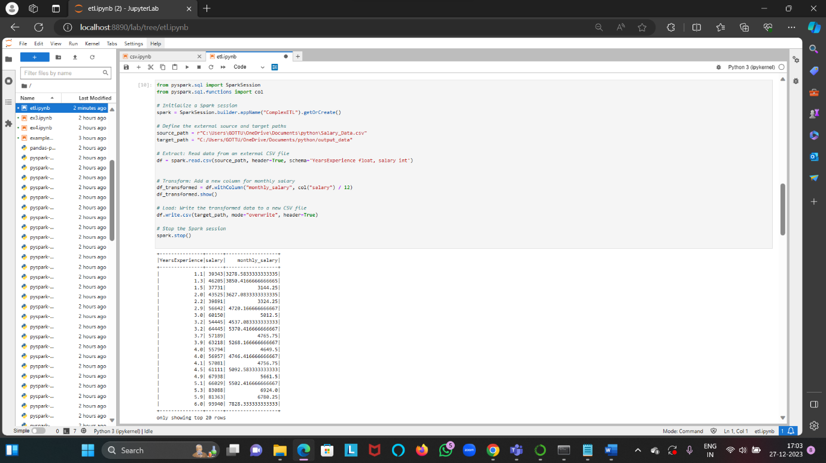

**Using Spark SQL - Creating databases, tables:**

Created a new database called “company” and table called “employee_data”.

Table contains columns (employee_id, name, age , department)

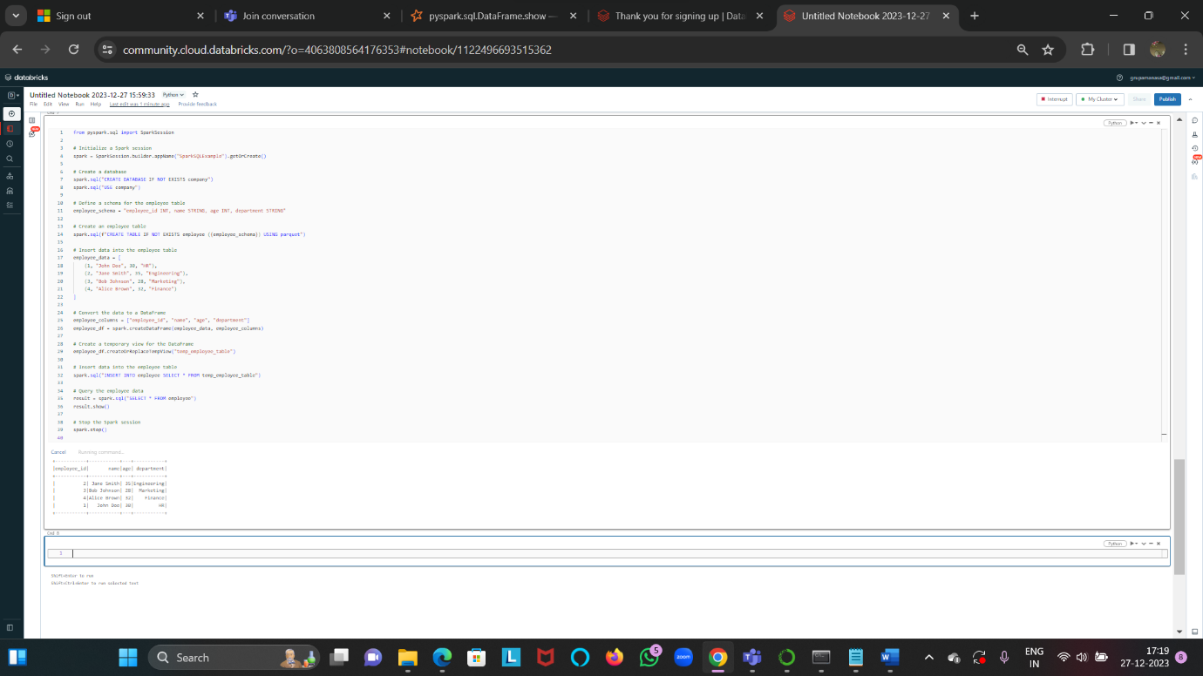

**Using Spark SQL - Transformations such as Filter, Join, Simple Aggregations, GroupBy:**

Created two tables employee_data and department_data.

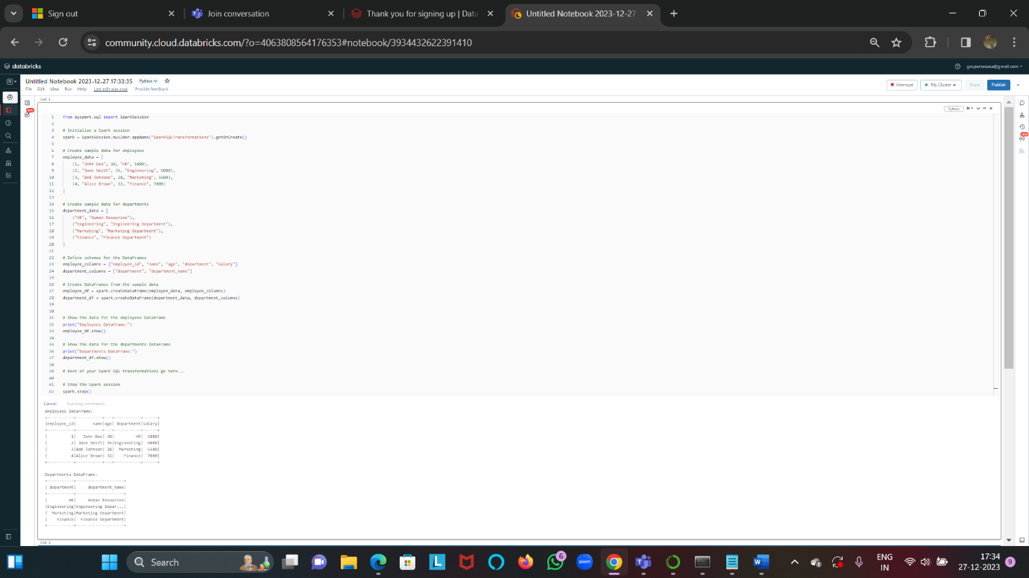

**Filter, Join, Simple Aggregations, GroupBy:**

Filtering employees older than 30

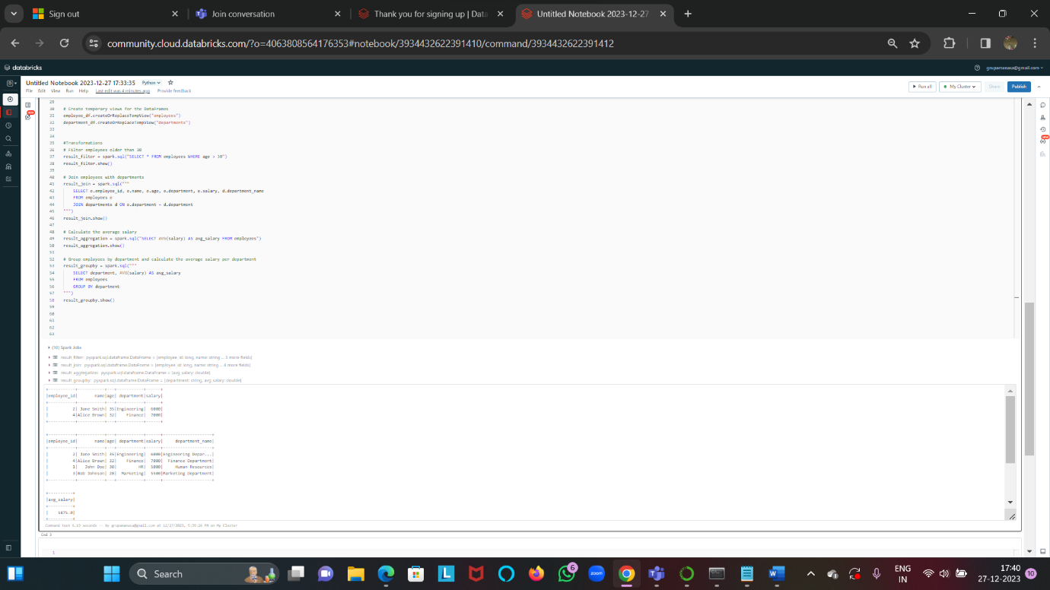

Joining employees with departments

Calculating Average salary(aggregate function)

Group employees by department and calculate the average salary per department(groupby)

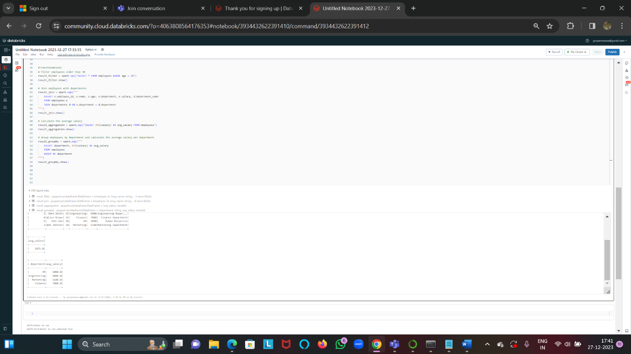

Outputs of Transformations

